**Deliverable #4: Investigating PCB in the Lab**

**Project: IoT Vulnerability Research Project**

**Participants:**

* Vikram Kher
* Varin Jaggi
* Tarik Wilkinson
* Patrick Kakooza
* Liza Moody
* Haoda Wang

**Introduction:**

For deliverable 4, one of our primary goals was to thoroughly examine which connections on the PCB board were active. To accomplish this, we went to the OHE240 lab at USC where we had access to a multimeter and an oscilloscope. Through the use of the oscilloscope in particular, we were able to determine several active connections, which we stated further down in the document. Another one of the primary goals of this deliverable was to configure our raspberry pi to act as a UART transmitter and receiver device. We encountered some difficulties with getting the raspberry pi running, which we will tackle in the next deliverable. We would like to configure the raspberry pi device so that it can input commands to the LaView camera.

**Lab Setup :**

(Pictures with active pins and serial data in the end)

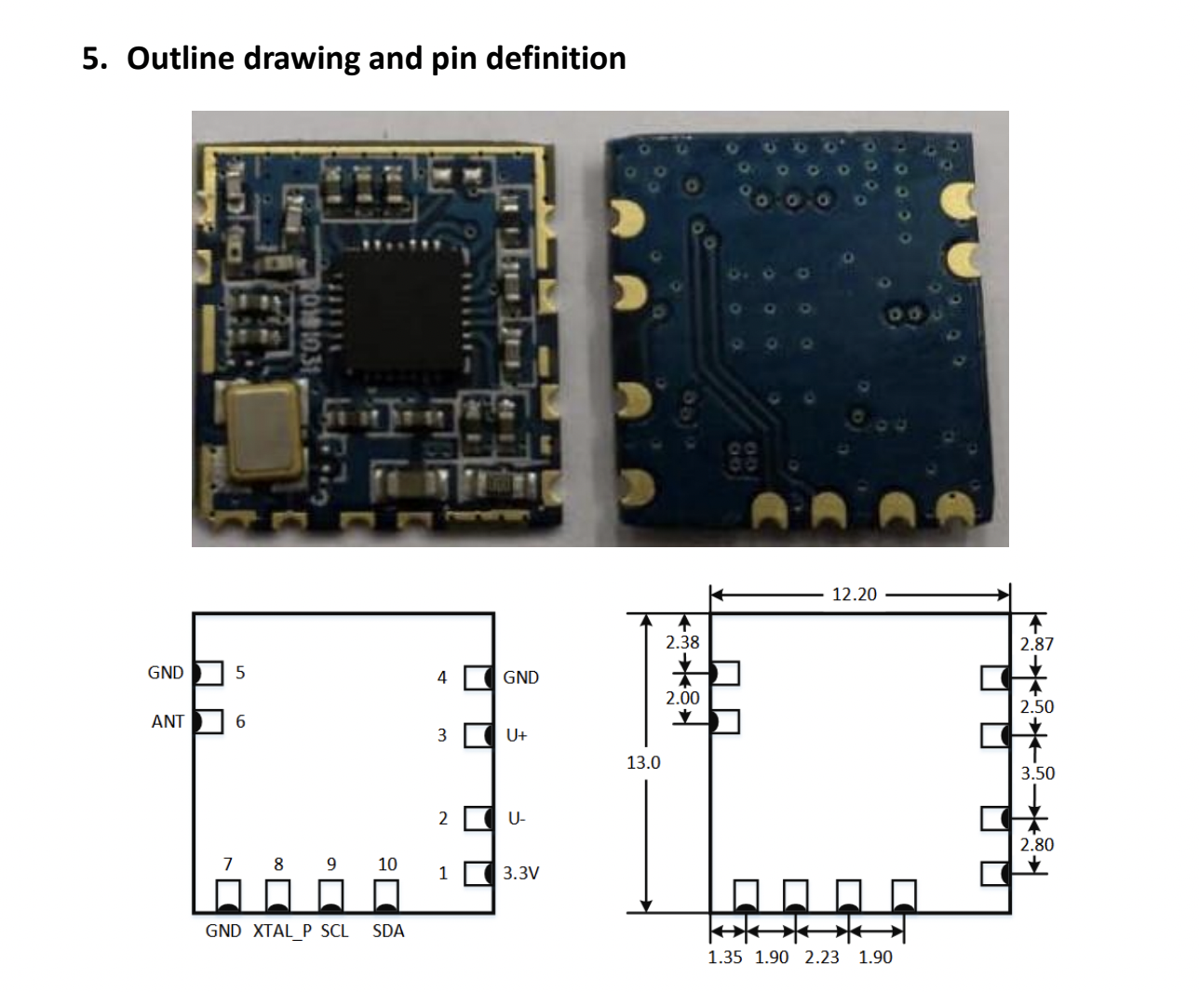

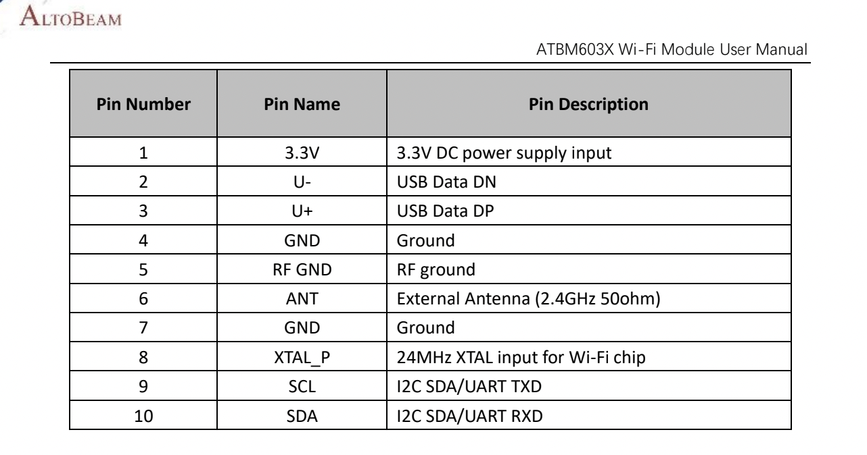

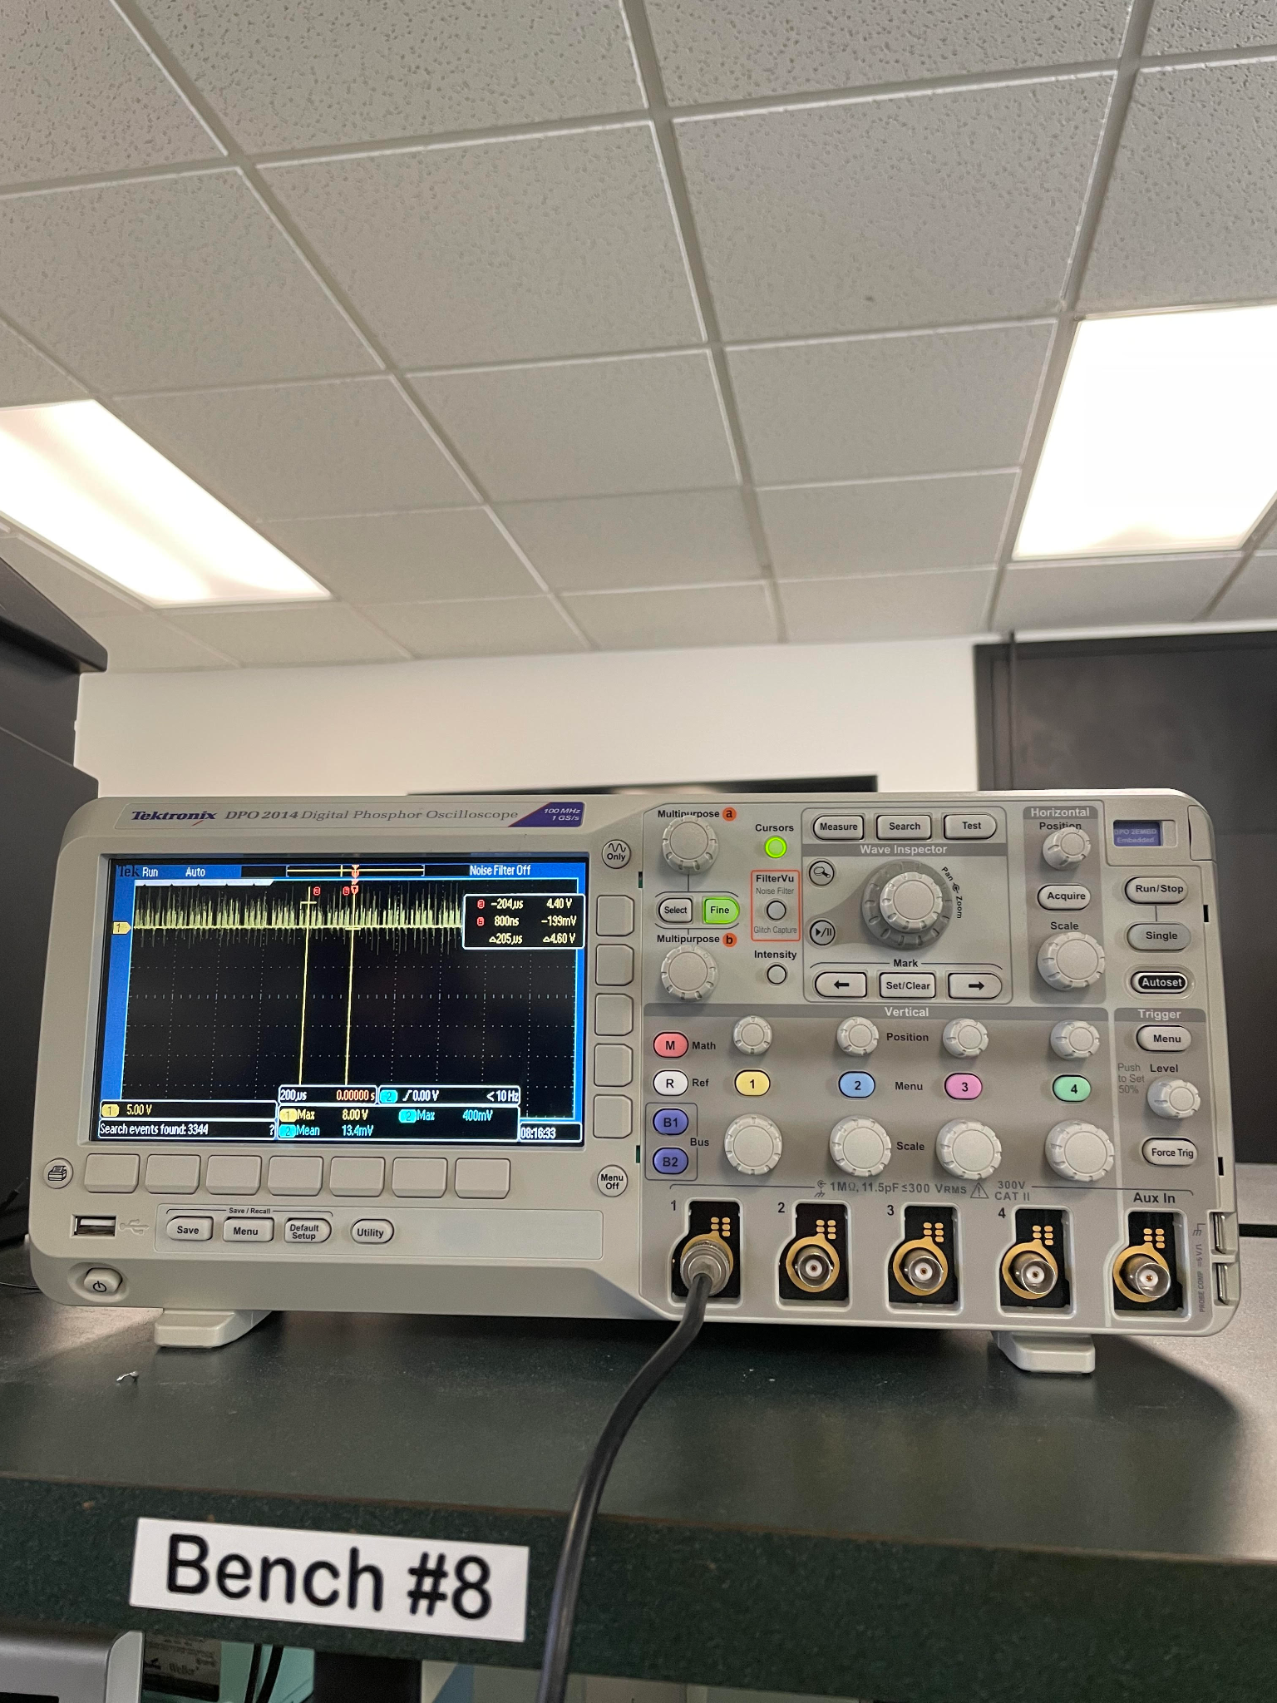

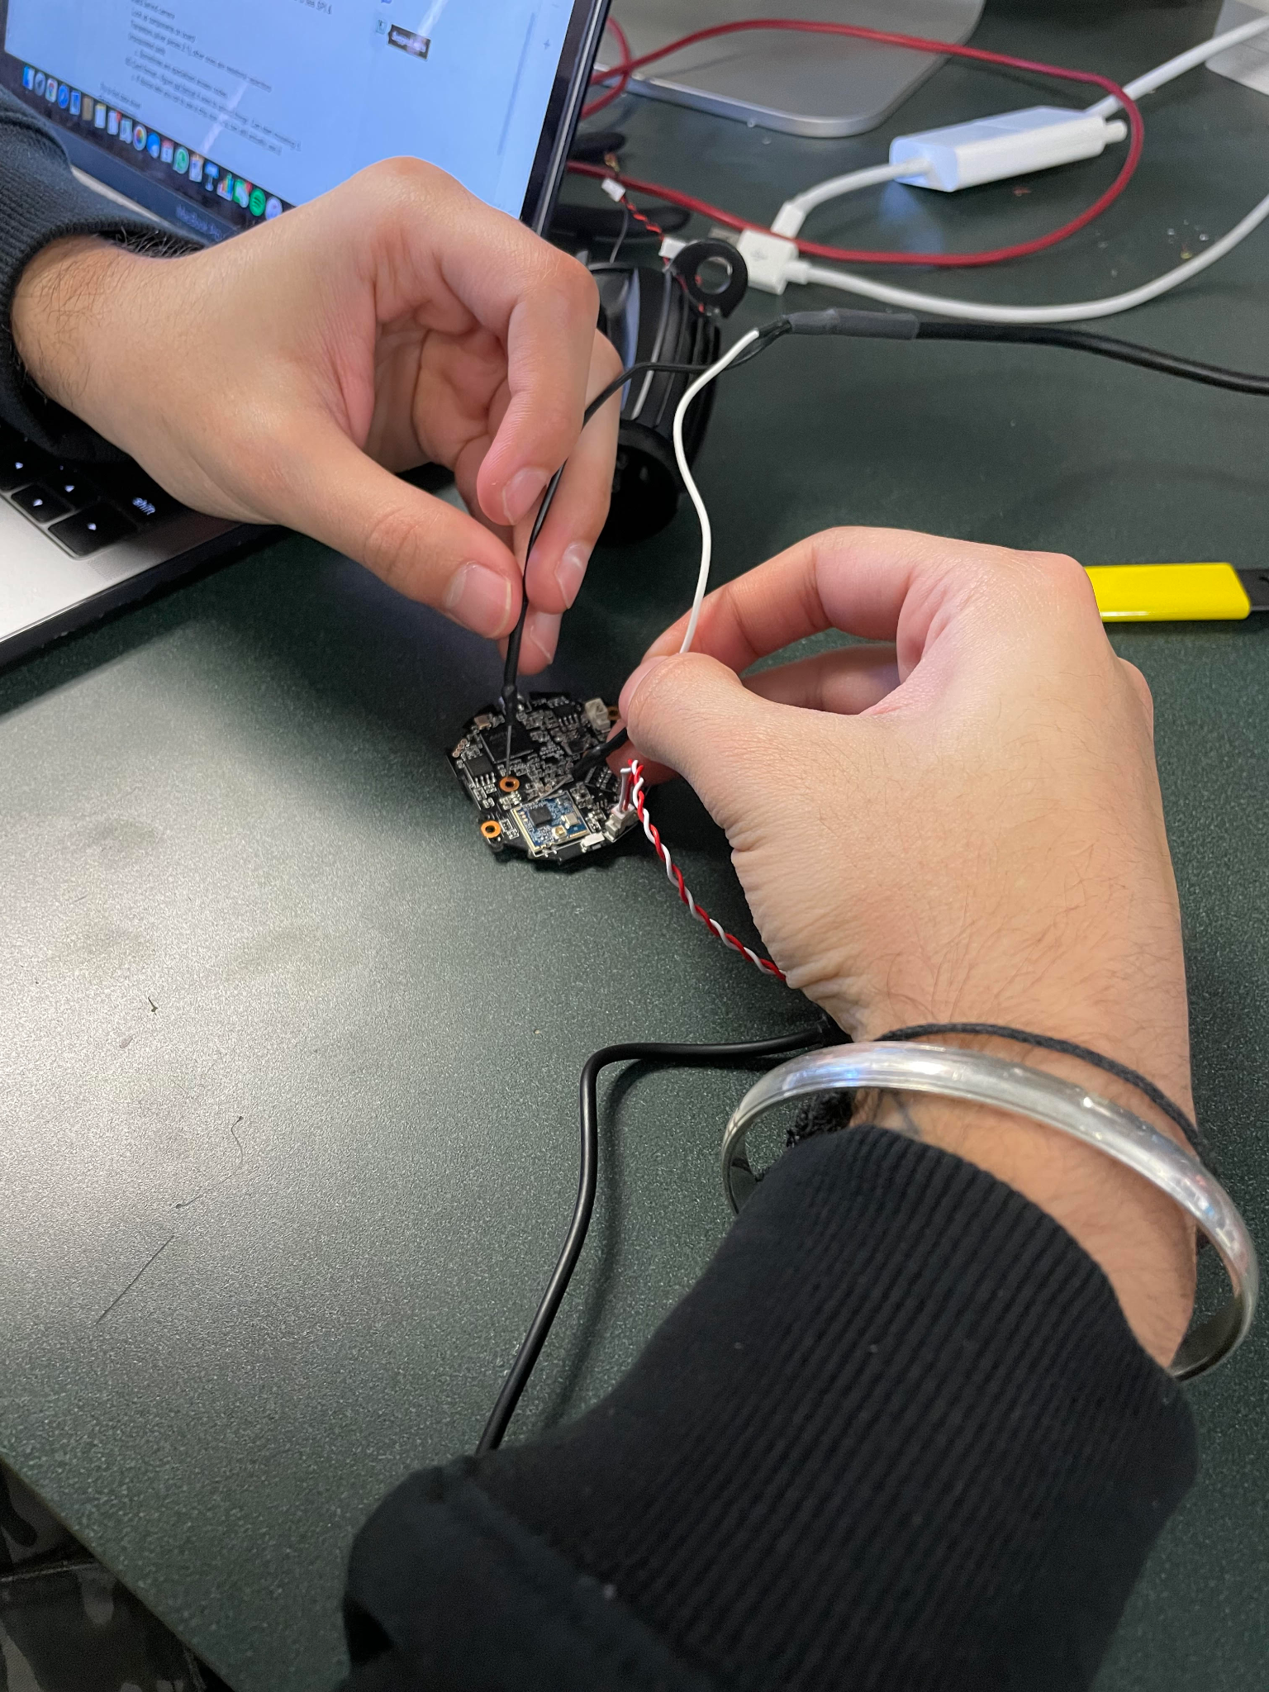

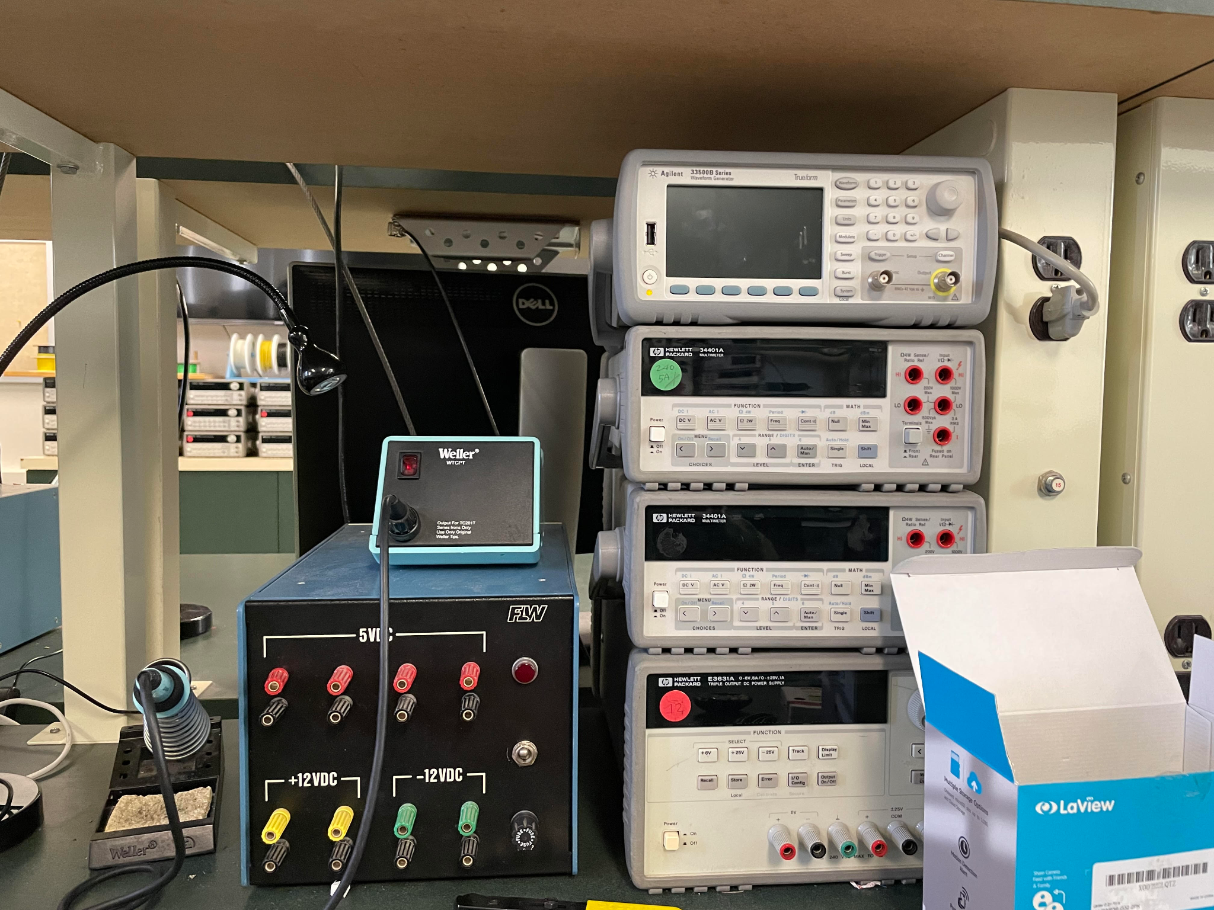

**Front of Chip (4 active pins found - circled in red):**

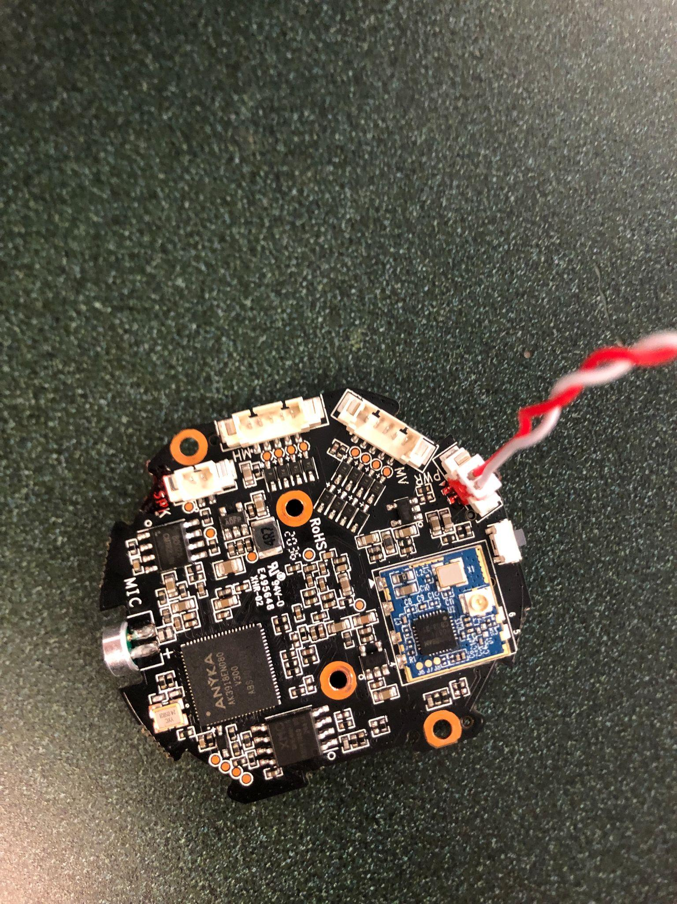

**Back of Chip (6 active pins found - circled in red):**

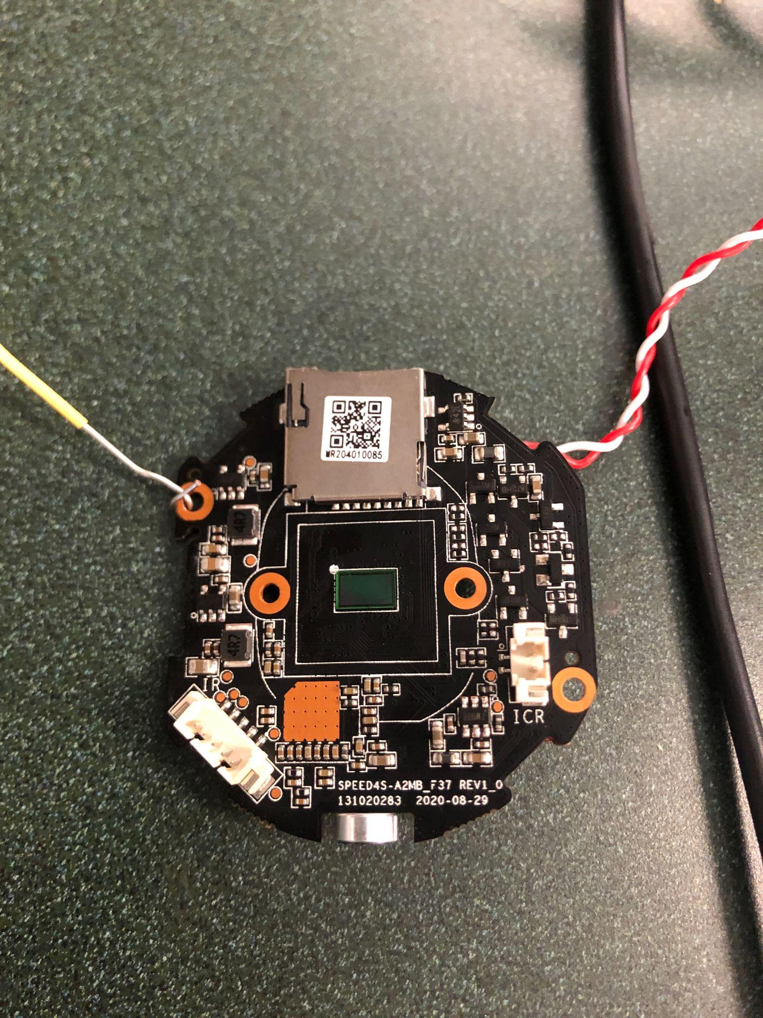

**Pins found transmitting serial data (circled in yellow):**



Yellow is receive

Orange is transmit

Black is ground

Red is 5 voltsr